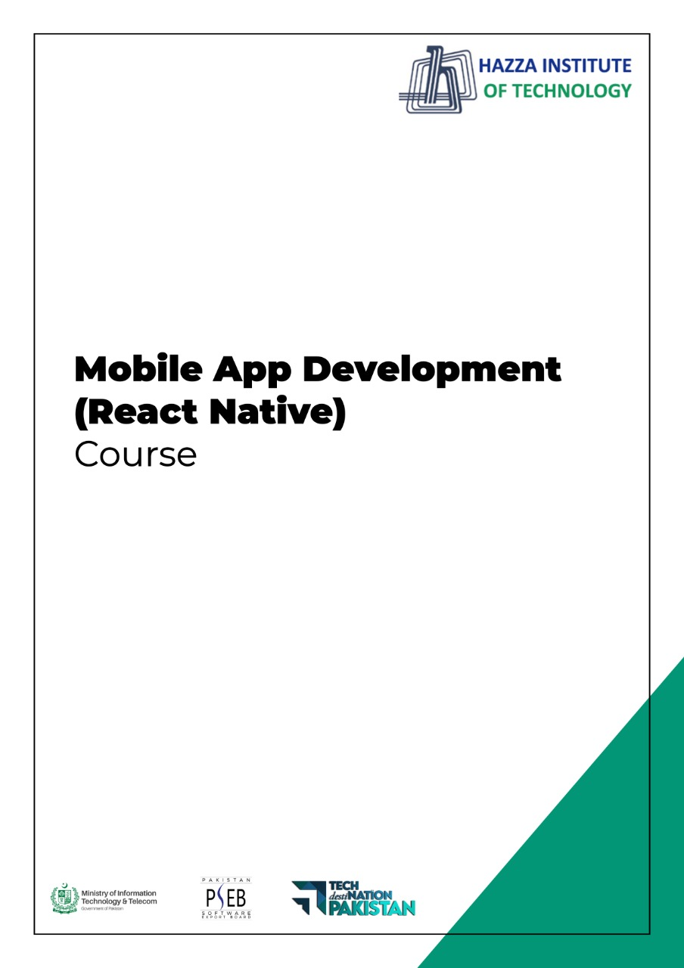
(Flutter)
Flutter Lab 4 (Session 2)

Total Time:
3 hours

Pre-Lab Activities:
  - Students should familier with layout widgets
  - Student should complete week three slides before this lab.

Learning Outcomes:
  - Student will learn about Layout Design
  - Student will learn single/multiple child widgets

Student Activities:
  - Student use the Android Studio for Flutter
  - Student use different layout widget to desgin UI

Lab Tasks 3:
  - Desing the User Interface according to given Layout
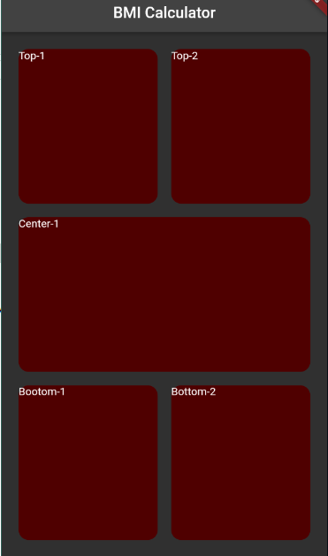

Lab Solutions:

LAB 4.3 : Practicing Layout Designing.

CODE:
body: Container(
margin: EdgeInsets.all(15),
child: Column(
children: [
Expanded(
child: Container(
child: Row(
children: [
Expanded(child: Container( margin: EdgeInsets.all(10),width: double.infinity, height: double.infinity, child: Text('Top-1'),
decoration: BoxDecoration(borderRadius: BorderRadius.circular(15), color: Color(0xFF4F0000)),),),
Expanded(child: Container( margin: EdgeInsets.all(10), width: double.infinity, height: double.infinity, child: Text('Top-2'),
decoration: BoxDecoration(borderRadius: BorderRadius.circular(15), color: Color(0xFF4F0000)))),
],
),
),
),
Expanded(
child: Container(
margin: EdgeInsets.all(10),
width: double.infinity,
height: double.infinity,
child: Text('Center-1'),
decoration: BoxDecoration(color: Color(0xFF4F0000), borderRadius: BorderRadius.circular(15)),),),
Expanded(
child: Container(
child: Row(
children: [
Expanded(child: Container(margin: EdgeInsets.all(10), width: double.infinity, height: double.infinity, child: Text('Bootom-1'),
decoration: BoxDecoration(color: Color(0xFF4F0000),borderRadius: BorderRadius.circular(15)),)),
Expanded(child: Container(margin: EdgeInsets.all(10), width: double.infinity, height: double.infinity, child: Text('Bottom-2'),
decoration: BoxDecoration(color: Color(0xFF4F0000), borderRadius: BorderRadius.circular(15)),)),
],
),
),
),
],
),

